2025 Teche-Vermilion Regional Flood Management Plan

V1.7

Objective and Executive Summary
The intent of the plan is to minimize the risk of a major flood event in the Teche-Vermilion Watershed to the extent possible by entities that have some control over water levels in the watershed.

Method defined by the Plan
The method employed consists of lowering stages of major tributaries in advance in anticipation of a forecasted major rain event utilizing existing control structures, systems, and resources. This objective of this process is to establish retention for a portion of the expected rainfall. Additionally, efforts will be executed to position gates and related water control systems to facilitate the efficient and safe movement of flood waters to the watershed natural flood plains and ultimately to the Gulf of America.

Entities Involved in Operation of Plan
Bayou Vermilion District (BVD) Plan Administrator and Operations Coordinator
US Army Corps of Engineers(USACE)
Teche -Vermilion Freshwater District(TVFD)
St. Martin Parish Government and LA Wildlife and Fisheries
Rapides Parish Police Jury
Red River, Atchafalaya and Bayou Boeuf Levee District (RRABB)
Parish Drainage Departments
Team Citizen Volunteers as needed

Systems, Control Structures, and Resources and Controlling Entity addressed by Plan

US Army Corps of Engineers Control Structures

Bayou Courtableau Water Control Structure
Provides drainage of Bayou Courtableau into the West Atchafalaya Spillway just south of US190 East of Port Barre
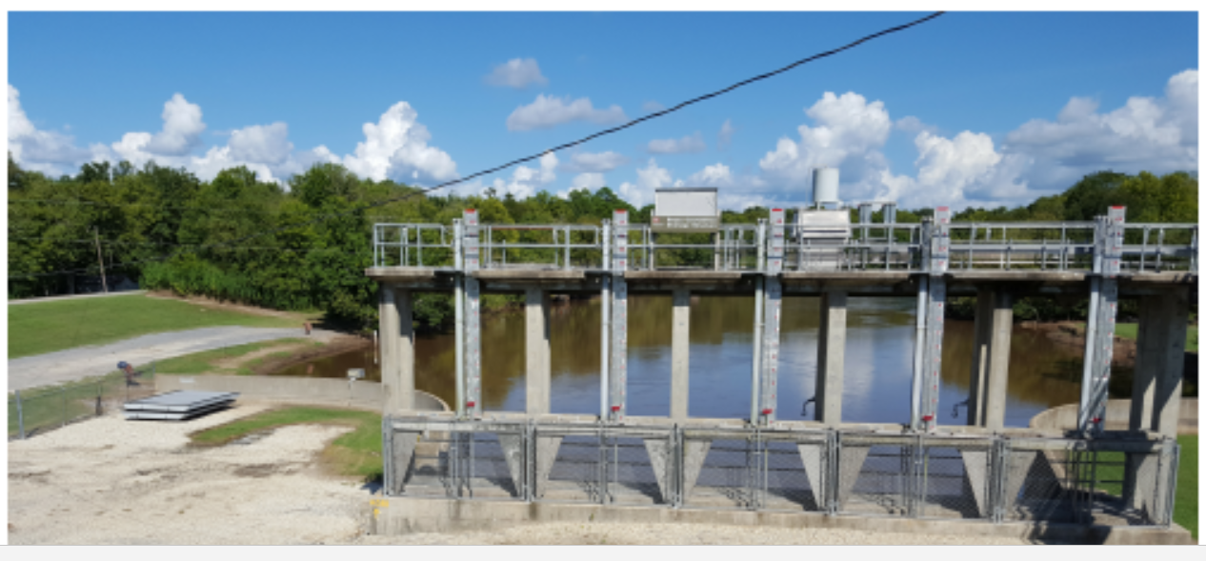

Darbonne control structure
Provides drainage of Bayou Courtableau into the West Atchafalaya Spillway just north of US190 East of Port Barre
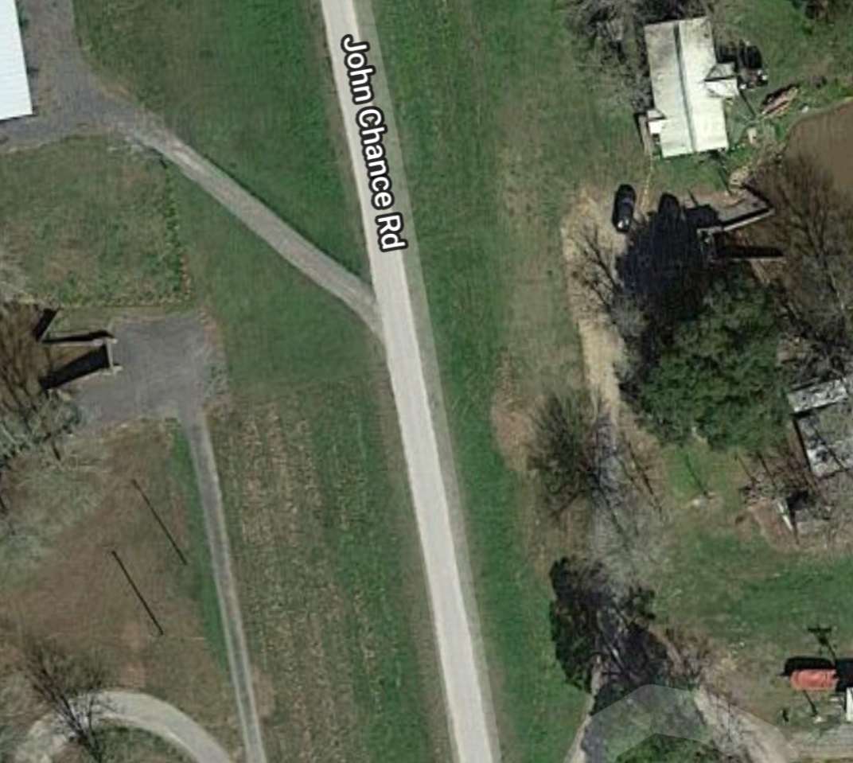

Teche Vermilion Freshwater District Control Structures

Pumping Station
This pumping station is located north of Krotz Springs pumps fresh water from the Atchafalaya River for the Bayou Teche and Vermilion River to improve water quality and prevent salt water intrusion
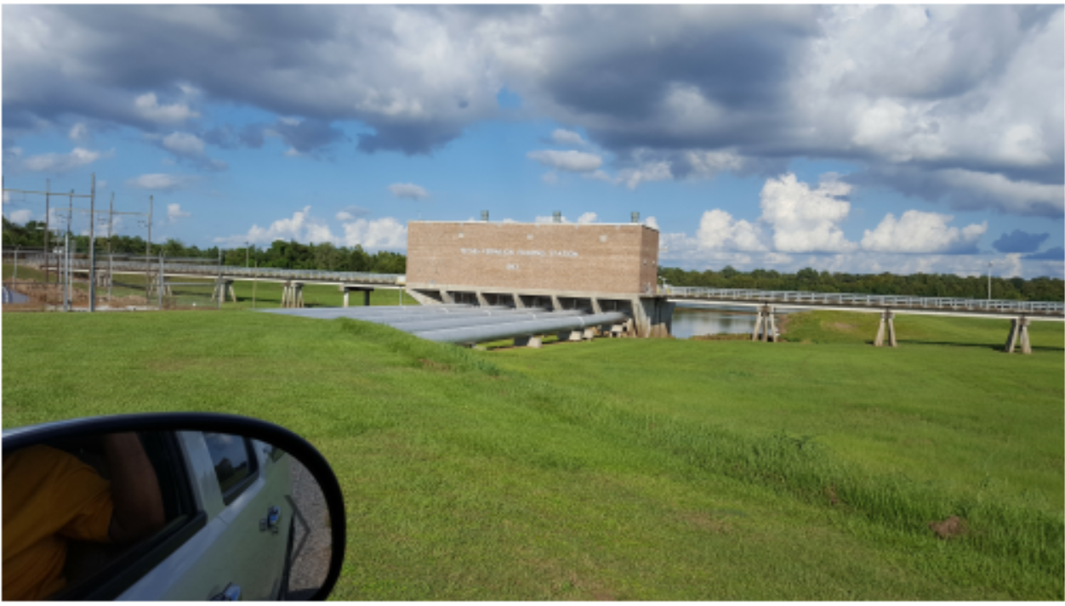

Ruth Canal Diversion Structure
Gate on Ruth Canal just West of Bayou Teche South of Breaux Bridge controls water flow from Bayou Teche to the Vermilion River
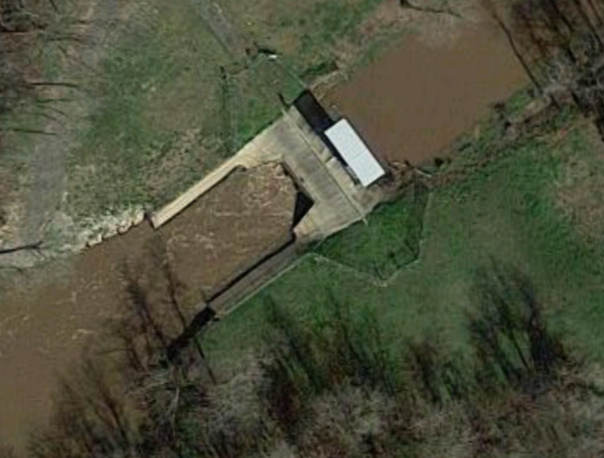

Loreauville Canal control structure
Control Structure on Loreauville Canal East of Bayou Teche- controls water flow into Lake Fausse Pointe from Bayou Teche
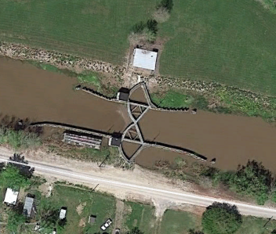

Feeder canal/borrow pit control structure
Gate on Borrow Pit Canal near West Atchafalaya Spillway West Levee provides drainage from Bayou Courtableau into the West Atchafalaya Spillway West Levee Borrow Pit
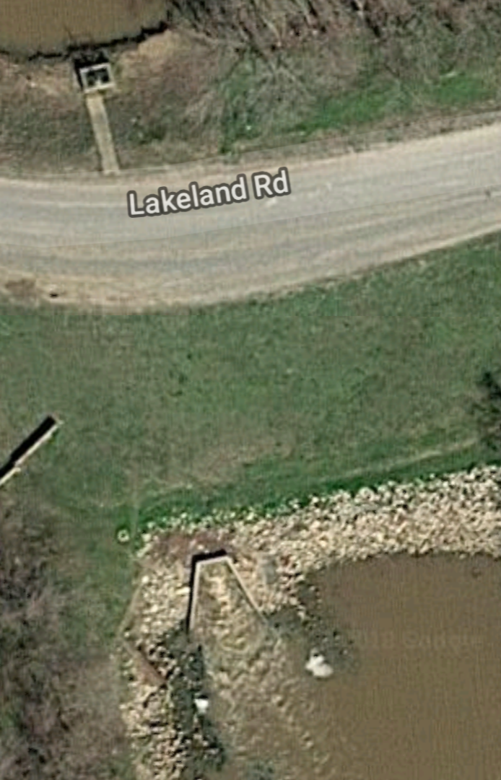

St. Martin Parish Government and LA Wildlife and Fisheries

Henderson Lake Southern Control Structure
This structure manages the level in Henderson Lake and is located south of the Butte La Rose pontoon bridge
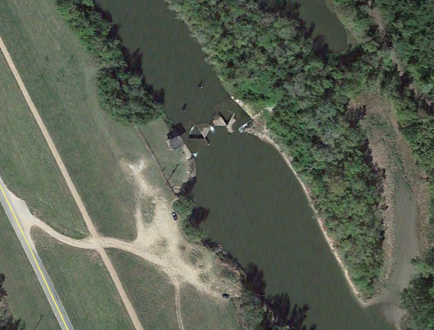

Red River, Atchafalaya and Bayou Boeuf Levee District

Bayou Rapides-Bayou Boeuf Gates
The first gate below is located between Bayou Rapides and Bayou Boeuf just west of downtown Alexandra LA .
The second gate below is located between Bayou Rapides and the Red River just north and west of downtown Alexandra LA.
Both gates may be operated in sequence to provide irrigation waters to farm operations along Bayou Boeuf in the northern and central areas of the watershed.
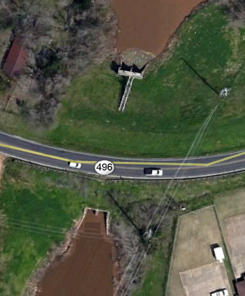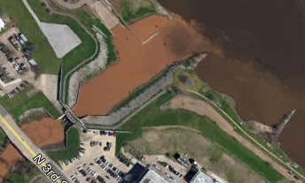

Rapides Parish Police Jury

Kincaid and Indian Creek Lakes

Both lake’s gates may occasionally be operated in sequence to provide irrigation waters to farm operations along Bayou Boeuf and Cocodrie in the northern and central areas of the watershed.
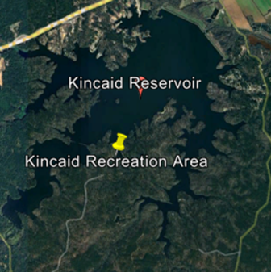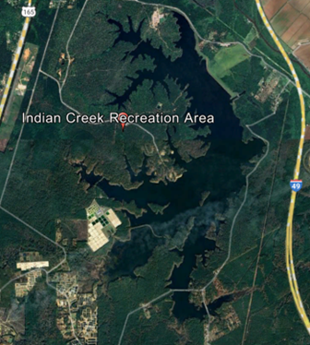
Plan Timetable Events

When a Rain Event is Forecast that could result in a Flood Event

As necessary as soon as a Major Regional Rain Forecast (8” of greater) is made for the Teche-Vermilion Watershed

Or

The National Hurricane Center issues tracking models forecast that project a potential tropical system(depression, tropical storm, or hurricane) landfall on the Louisiana coast west of the mouth of the Mississippi River west to the Texas border.
A conference call for all the Operational Entities will be scheduled by the Plan Administrator and Operations Coordinator and executed ASAP no later than 72 hours (3 days) prior to the forecast beginning of the rain event.
If current pool stages of Lake Pelba in St Martin Parish and the Red River in Alexandria Rapides Parish are sufficiently high enough that prevent drainage then the conference call for all the Operational Entities will be scheduled no later than 96 hours(4 days) prior to the forecast rain event or tropical system landfall. The Operation Plan will be activated immediately at the commencement of this meeting.

Action Plan

72 Hours(or sooner) Prior to a Forecasted Major Regional Rain Event (8” of greater) or Tropical System Landfall
In order to lower stages in the Bayou Courtableau and the Teche-Vermilion watersheds quickly the following operations of control systems and control structures and will be executed ASAP.
- Teche-Vermilion Freshwater District Pumping Station ceases any pumping operations
- Red River, Atchafalaya and Bayou Boeuf Levee District will open the Bayou Rapides gate when river side levels are lower than bayou side levels and remain open until backflow occurs. Additionally, Bayou Boeuf gates will be closed if open providing irrigation water to the lower part of the watershed. Rapides Parish Police Jury for Kincaid and Indian Creek drainage gates will be closed if open providing irrigation water to the lower part of the watershed.
- The USACE Bayou Courtableau Water Control Structure is opened when Lake Pelba basin side levels are lower than bayou side levels and remain open until backflow occurs or targeted drawdown levels are achieved which is approximately 15.63 ft, the same annual operating pool stage level during the month of December.
- The TVFD Feeder canal/borrow pit control structure is opened(Bayou Amy Gate)
- The USACE Darbonne control structure is opened when Lake Pelba basin side levels are lower than bayou side levels and remain open until backflow occurs
- The Ruth Canal Diversion Structure is closed
- Coordinating with LA Wildlife and Fisheries, if Henderson Lake is not already in a drawdown, the Henderson Lake Southern Control Structure gate will be opened by St Martin Parish and will remain open until the threat has passed.
- Loreauville Canal control structure gate is opened when the gauge at the upstream side(Bayou Teche side) of the structure is greater than 4 ft
- The Plan Operations Coordinator will record a time and date log of when each operations step is executed. Additionally, recording of hourly level data will be made on critical gauge data to help understand how this Operation Plan impacts levels in the watershed.
- Parish Drainage Departments will survey all critical bridge crossings for potential plugging by debris and take appropriate action. This is especially important on the W Port St Bridge over the Vermilion river in Abbeville which experienced severe plugging during the 2016 flood.
- Citizen Volunteers assist with on the ground observations and monitoring where data is limited

Daily until Threat has passed
Follow up conference calls for all the Operational Entities will be held daily by the Plan Operations Coordinator until the threat of the major flood event has passed.

After the Rain Event or Flood Event has passed
The Plan Operations Coordinator will determine when the rain or flood event risk has passed and notify all of the entities to return all gates and control systems and structures to their respective normal operations as soon as feasible.

Plan Contact List
Entity Name Position
Phone eMail
BVD
Stephen Broussard BVD Executive Director
(337)581-3369(cell) ed@bayouvermiliondistrict.org
USACE
Russell Beauvais USACE Operations Manager Old River Control Structure
(225)202-3851 (cell) Russell.A.Beauvais@usace.army.mil
TVFD Donald Sagrera Executive Director
(337)652-0496(cell) sagreral@aol.com
St Martin Parish Sherbin Collette Mayor of Henderson, LA
(337)319-5267 hendersonla@cox-internet.com
RRABB Levee District Ryan Ingles Executive Director
(318)443-9646(cell) ringles@rrabb.net
Rapides Parish Police Jury Corey Ashmore Superintendent
(318)473-6603
Citizen Volunteers
St. Landry Parish Harold Taylor Parish Council District 5
(337)945-3661(cell) harold.taylor@lhcgroup.com
St. Landry Parish Ricky Broussard Retired
(337)308-4545(cell) rickyb54@att.net
BVD Dave Dixon Commissioner Bayou Vermilion District President Dredge the Vermilion, Inc.
(337)739-9331 daveralphdixon@gmail.com
Lafayette Parish Brent Logan Retired
Secretary Treasurer Dredge the Vermilion, Inc.
(337)278-6601 brentloganla@gmail.com

